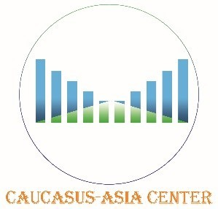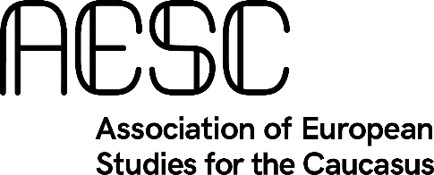

Exploring opportunities for cooperation between Europe and South Asia in the South Caucasus region

In September 2019, the European Union (EU) and Japan signed a holistic partnership intended to promote investment and development projects and characterised by principles of rules-based connectivity and sustainability. The deal will cover all dimensions of connectivity - including digital, transport-related, energy and people-to-people exchanges. It also considers other crucial aspects such as environmental awareness and protections as well as quality infrastructure. The deepening of this comprehensive collaboration is not limited to a specific geographic area. Instead it is open and inclusive, ambitioning to cover all territories ‘from the Indo-Pacific to the Western Balkans and Africa’. As such, the new agreement between Brussels and Tokyo not only determines a crucial constituent of the overall ‘EU Strategy on Connecting Europe and Asia’ (which is part of the ‘EU’s Global Strategy’) but has also a strong potential to flank and strengthen both the ‘EU Strategy on India’, and the ‘EU Strategy on Central Asia’. In spite of being included in the EU’s Eastern Partnership Programme, Brussels has yet to formulate an explicit strategy regarding the South Caucasus area. Yet this extraordinarily complex region is geographically well positioned to function as a bridge between different Asian regions and between these and the EU. Making use of the various instruments and frameworks of European engagement in cross-regional connectivity, the South Caucasus could serve not only as a destination for EU-supported development projects - including multi-national projects engaging both local and extra-regional actors such as India and Japan - but also as a link between different connectivity ambitions. The South Caucasus has historically been a

European gateway to Asia - in particular to South Asia; much trade and mutual engagement has taken place and could again. The EU itself of course should participate and even take the lead in realising a renewed connectivity in the 21st century so as to reinforce both its links with South Asia and its vision across Eurasia as a whole.
Having this in mind, the SADF Round table, which is jointly organised with the ‘Centre for South Caucasus-South Asia Business Development’ and the ‘Association of European Studies for the Caucasus’, will explore and discuss different venues of potential cooperation between Asia and Europe - with special focus on the South Caucasus. The considered topics will include geopolitical, geo-economical, and socio-cultural aspects.

Format of the event:
- Round table; 90 to 120 minutes (depending on the number or speakers);
- Venue: office of the South Asia Democratic Forum (SADF), Brussels
- Date & Timing: Thursday 07 November 2019, from 14H30 to 17H00
- Maximum number of participants (speakers & audience): 20

Programme:
Moderation: Dr Thomas Kruessmann, Senior Research Associate, Global Europe Centre University of Kent, and President of the Association of European Studies for the Caucasus

Welcome:
by Paulo Casaca, Director of SADF

Brief introduction about Caucasus-Asia Center: Sandal Kakkar

Speaker’s session:

- Dr Siegfried O. Wolf, Director of Research, SADF
Topic: The role of Economic Corridors in regional cooperation and their significance in building connectivity

- Elchin Bashirov, Counsellor, Embassy of Azerbaijan
Topic: Azerbaijan connection perspectives in Southern Asia
- Tornike Mgaloblishvili, Senior Counsellor, Mission of Georgia to the EU
Topic: TBD

- Tinatin Tsertsvadze, Advocacy Director/ Gender Adviser International Partnership for Human Rights (IPHR)
Topic: Present state of Democracy and Rule of Law in South Caucasus: a catalyst or a repeal for global trade?

- Natalia Mirimanova, Director at Eurasia Peace Inititatives
Topic: Role of non-state actors: a catalyst towards establishing inter-regional connectivity and cooperation?

- Hriday Ch. Sarma, Founder & Team-Coordinator for the Caucasus-Asia Centre
Topic: Historic trade routes evolving as 21st century corridors for contestation or cooperation? Importance of historic monuments symbolising the other in one’s land, such as the Armenian Church Chennai, Fire Temple of Baku, etc.

